**1. (output to terminal)**

**Write a script to print:**

**a. “Welcome to Intelligrape”**

**b. <username>@<hostname>:<your present working directory>**

1. Create a file script1.sh

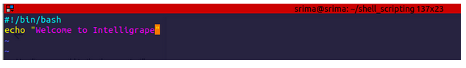

Make it executable for the current user

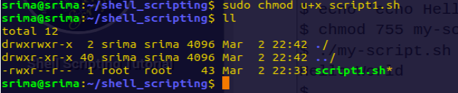

Execute the script



b)





**2 (arguments)Write a script**

**a. which takes in two arguments and print those arguments.**

**b. which checks the number of arguments passed and if the number is greater than two print ERROR message along with printing the number of arguments.**

1. script1.sh



Run the script , pass the arguments from command line



b) 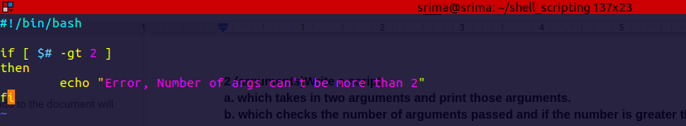



**3. Continue with the above script**

**a. check the two arguments are only integer values and if these are not integers print the proper error on terminal and also log it into a file.**

**b. perform addition on the two arguments and print result on screen. Use function for this.**

a)

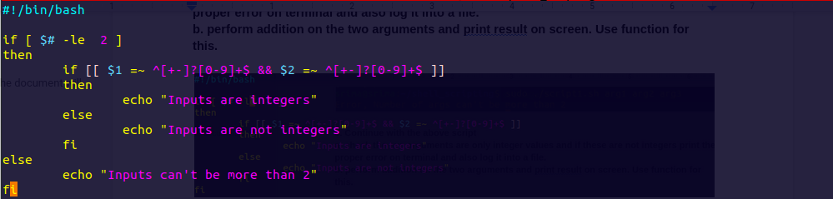







b) 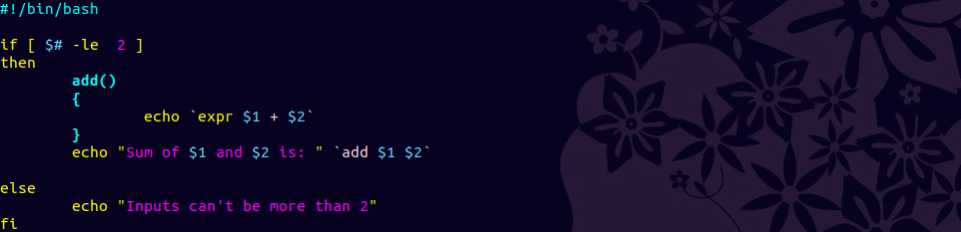



**4. Create a calculator using the above script which would perform addition,subtraction,division and multiplication.**

**a. the script should ask user which operation the user wants to perform:+,-,*,/**

**b. if user enters other than “+.-,*,/”, print a proper message on the terminal and keep on asking for correct input(use while loop to accomplish this).**

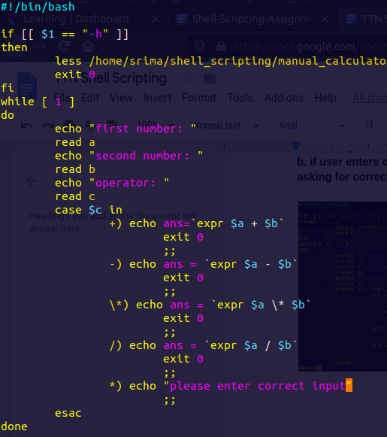

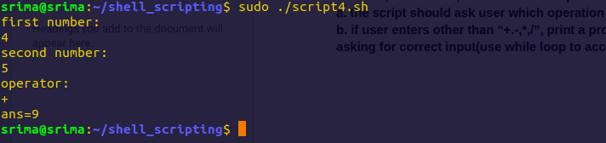

b) Output on wrong input

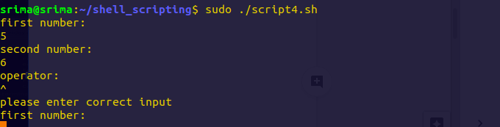

**5. Write proper help documentation and print it with -h for above script.**

Give -h while running script



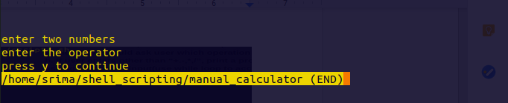

:

**6. Create a script which takes input of "/etc/passwd" file and find out and print the sum of uids and gids. The script should tell which sum of greater.**

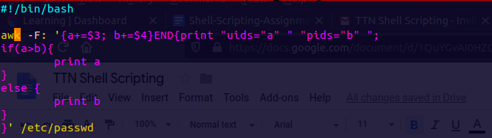



**7. A directory contains files and sub-directories. Move files to destination1 and directories to destination2**

Create directories for demonstration

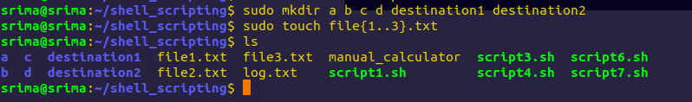

Script for moving files is destination1 and directories in destination 2

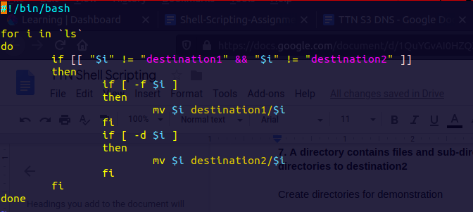

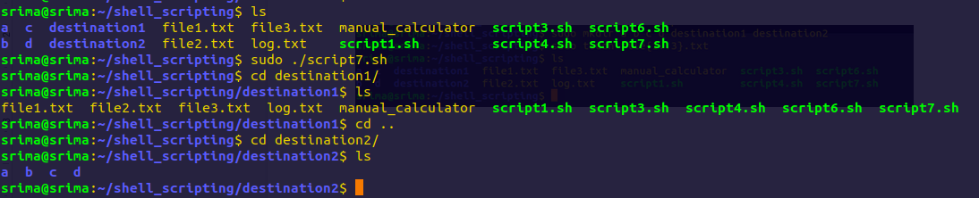

**8. Create a script which take three arguments, append first argument to every line in a file and second argument to the end of every line of the same file..**

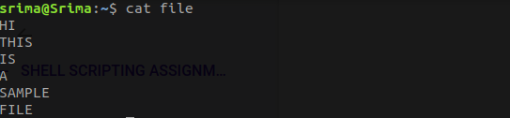



On running this script

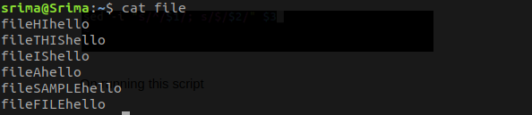

**9. Make a list of files in /usr/bin that have the letter "a" as the second character. Put the result in a temporary file.**

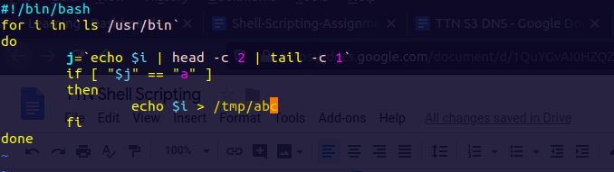

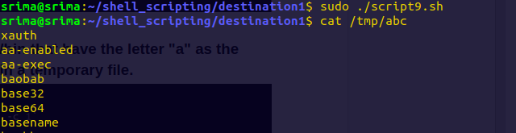

**10. List all files in your home directory and print name and size in a table format.**

Script

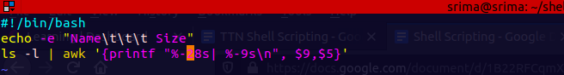

Output

